How to save the settings into a text file from your router or switch

Richt click on the border of putty to give the menu

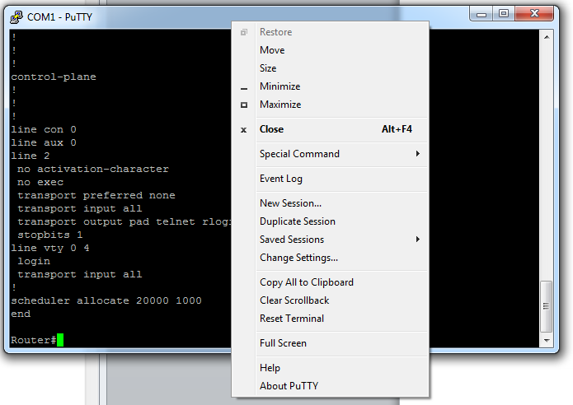

Click on Clear Scrollback
And then Reset Terminal

To give a blank putty window
In putty at the enable level type the command show run
This will show the running configuration. Hit the space bar everytime the window shows ---More---
Until the process has finished.

Now right click on the edge of the putty window again and select Copy All To Clipboard

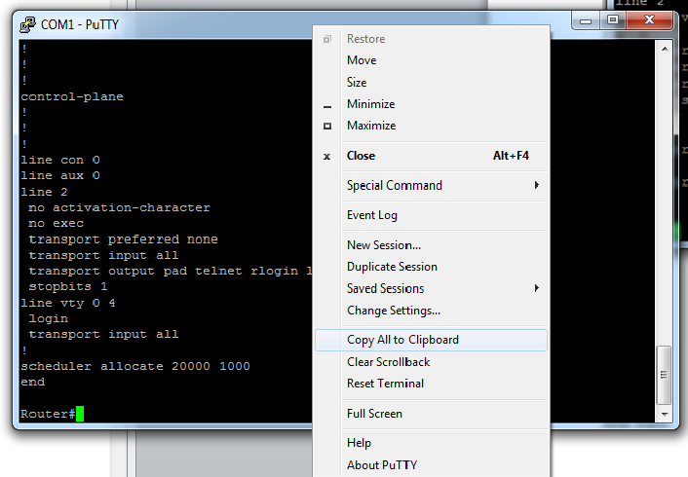

Open up notepad and paste the text from the clipboard into an empty page
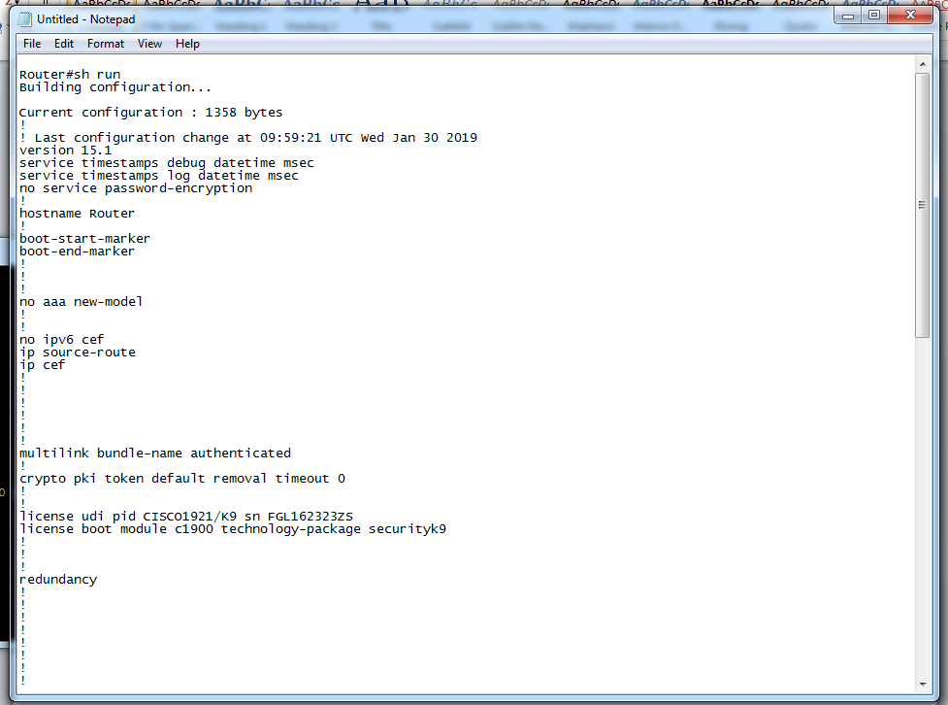

Edit the text file to remove the lines shown in the red boxes above and the router prompt which is the last line in the text file
Now save the text file

Reloading the settings onto your router or switch
With the router booted up type enable
And then configure terminal

In your text file copy all onto the clipboard and then in putty at the prompt right click and all your settings will be loaded on



